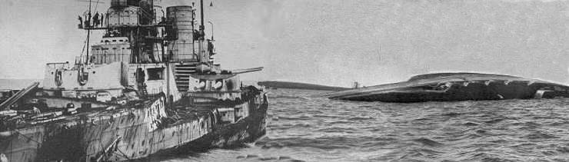

Wrecks of Scapa Flow

BSAC 1018 ‘SCAPA 2006’

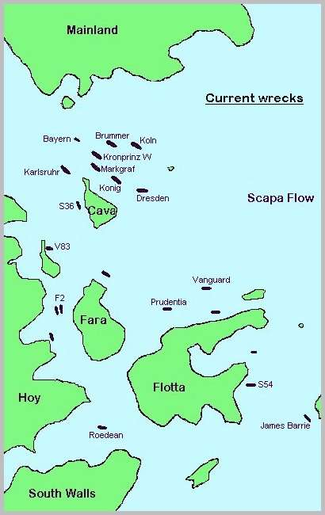

Organised by John Campbell

Index:

Wreck Depth Page

- Bremse (10m) 3
- Karlsruhe (12-26m) 3
- Kronprinz Wilhelm (12-38m) 4
- Roedean (15m) 7
- B109 (15m) 7
- V83 Destroyer (16m) 7
- Gobernador Bories (16m) 8
- F2 Escort Vessel (18m) 11
- Dresden (18-35m) 11
- Köln (20-35m) 12
- Brummer (20-36m) 14
- Koenig (20-40m) 17
- Markgraf (24-45m) 17
- General information on Scapa diving 18
- Information on Stromness 19

All information is from the web site: http://atschool.eduweb.co.uk/jralston/rk/scapa/
Wreck tours from divernet: http://www.divernet.com/wrecks/wrecktours.shtml
Also http://www.mvhalton.co.uk/
http://www.divernet.com/travel/scapa0600.htm
http://www.technicaldivers.com/html/scapa_flow.html - good site goes into detail about the dives

Please click-on for further information, although all dive information is listed below.

Bremse (10m)
The Bremse's site is a scrap yard. Much of the boat was carried off to Lyness where it was broken up for salvage. The Bremse's remains lie off the foreshore at Toy Ness. There are some plates and shafts in 10m of water, while a 6-inch gun lies in slightly deeper water. All around there are isolated patches of debris such as a mast, a toilet and a mangled piece of superstructure.

Karlsruhe (12-26m)
The Karlsruhe is the shallowest of the High Seas Fleet. She lies in 26 metres with a minimum depth of 12 metres. The boat is quite badly broken in places, but is nonetheless a rattling good dive. She lies on her starboard side with her stern section relatively intact with capstans and mooring bollards still attached to a sloping quarterdeck. Her mid section has been extensively salvaged, but this means that parts of her structure are the more easily seen. Towards her bows there are two 6-inch guns that straddle the seabed having collapsed from the main deck housing. Her bows are intact and quite imposing. Anchor chains from the capstans lead out over the deck through hawse pipes set in the damaged deck. An anchor chain runs out along the seabed. She has an excellent control tower.
This is an excellent dive not least because the salvage damage has made some parts of the cruiser more obvious than in the more extant ones. The stern is quite impressive.

Kronprinz Wilhelm (12-38m)

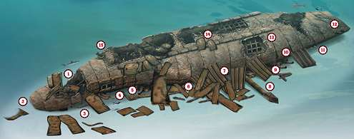
THE KRONPRINZ WILHELM IS AN ENORMOUS WRECK. On the cruiser wrecks of Scapa Flow it's possible to find your way round fairly easily, but on a battleship this large and complicated it can easily take a few dives before you get the feel for it.
The route I have chosen to describe is quite a long dive, involving a bit of a fast swim along the wreck to get the overall layout with diversions to see the main features. Even so, if you don't want to spend that much time under water and decompressing, it can easily be split into a series of dives.
Local dive boats usually maintain a couple of buoys on the Kronprinz Wilhelm, one at the stern and one amidships. I recommend the stern line, because if you start amidships and go down the wrong side of the wreck, you will lose several minutes of valuable bottom time working your way to the open side. Like many other divers, I've done exactly that.
The buoy line is attached among a jumble of debris where the hull has been blasted open just above the rudders (1). Salvage has removed the propellers and presumably the shafts to get at the bearings. Following the slope downwards, the debris ends and a more intact area of the hull continues to the seabed (2).
Go on down to the seabed and start swimming with the hull on your left-hand side. That way, wherever you hit the seabed you will end up on the open port side of the wreck, rather than the starboard side that rests in the silt.
Just forward of the rudders, a number of hull plates have come loose, providing easy access to the huge gear wheels which drove the stern anchor capstans, now buried in the silt below (3). Cabins in this area were the officers' accommodation, nice and comfortable away from the main machinery.
Back outside, a gap soon appears, growing between the deck and the silt. You could start exploring under the deck at any time, but an easy way to see the main gun turrets is to wait until the gap between the deck and the seabed is a few metres high before turning in beneath the wreck (4).
It's easy to miss the main gun turrets because they are so huge. I have found myself swimming alongside a turret and thinking it was just a wall of steel plate until I followed it up to the circular base.
Gun barrels for the 12in main guns could be mistaken for sections of propshaft or mast, until you suddenly realise just what it is you're looking at.
Find one that's clear of the seabed and try hugging it to touch your hands on the opposite side, and you'll see what I mean. The inside bore might be 12in, but the barrels are well over a metre in diameter at the base.
At the back of the number 5 turret is a gap between it and the deck. The turret base is still firmly attached to the deck, but in the lip at the back of the turret is an open hatch, originally leading upwards into the turret.
Now you can poke your head and dive down for a look inside at the breech mechanisms of the guns.
The number 4 turret was superimposed on number 5, being raised above it and just forward of it on the original ship. Turn this image upside-down and it's easy to find the guns for number 4 turret resting on the seabed below number 5, with the turret itself resting in the silt. The hatches at the back of this turret are firmly closed.
Following the deck above the turret back out to daylight, the first two of the secondary 5.9in guns are accessible (5), with the armoured casemate broken open to give a view of the breech mechanisms.
If you had not already seen the main turrets, these would be impressive in their own right, as big as the guns on the nearby cruiser wrecks. Here they are merely features of minor interest.
The main gun turrets have supported the hull in this area, keeping it clear of the seabed, but further forward the hull has twisted to bring the secondary armament level with the seabed.
Moving forward again along the port side of the deck, debris from the hull obscures much of interest, but poking in and out of the wreck where the gaps are large enough should reveal more of the secondary armament (6).
The number 3 main gun turret, situated amidships, is well buried beneath the wreck; obscured by the tangle of debris left from salvage work on the boilers and condensers (7).
About two-thirds of the way forward, lying perpendicular to the hull, lies a mast with observation platform (8).
Just forward of this, the foremost two secondary gun turrets are accessible beneath a pair of fallen hull plates (9). Now well forward of the engine- and boiler-rooms, debris from the salvage work is less of an obstruction, but the deck is closer to the seabed.
The number 2 turret is buried, but with a 1-2m gap between the deck and the silt there is just enough room to venture underneath again to see the number 1 main gun turret. The guns stretch forward half-buried in the silt (10).
Resting on top of one of the gun barrels is a length of anchor chain. Built on obviously battleship-sized proportions, each link is as big as a truck tyre and too heavy to shift even slightly.
Towards the edge of the deck are a pair of mooring bollards and a fairlead (11). The bows have collapsed almost flat to starboard, leaving two port anchor hawse pipes close together on the upper surface of the wreckage (12). The single starboard hawse pipe is hidden beneath the collapsed bows.
By now anyone diving on air will be well into decompression, and anyone diving on nitrox will be at their no-stop time. Rather than end the dive and ascend from here, a convenient way to move slowly shallower and get the most from a dive computer is to follow the hull back to the midships area, slowly making your way up the hull.
On the way in, there is access into internal corridors through gaps in the side of the hull (13), but be extremely careful because these are heavily silted.
This will eventually bring you up to a depth as shallow as 12-15m, depending on the tide. Ribs left poking into the gentle current are home to long and delicate anemones (14).
Forests of tunicates decorate intact plates, with carpets of intertwined brittlestars writhing on the deeper plates.
Although there is another buoy line here, you might not find it, so a delayed SMB could be necessary for decompression.
Further aft, the hole where the machinery was salvaged (15) provides a separate destination for a subsequent rummage dive.
The wreck of the Kronprinz Wilhelm is so immense and complex that you will need several dives before you even begin to feel you know it.
A wreck this size could merit a week's diving by itself, and whether you can spare that with all the other Grand Fleet wrecks and the blockships to explore, only you can decide.
She was one of the biggest warships in the world. After her launch at Kiel in 1914, the Kiel Canal had to be widened to get the huge Kronprinz Wilhelm through to fight Britain's equally massive Dreadnoughts, writes Kendall McDonald.
The Kronprinz Wilhelm weighed 25,388 tons, with her main armour plate over a foot thick around her turrets and fire control tower and another 4in of armour covering her decks. She was 575ft long with a beam of 97ft and a draught of more than 30ft. Into this was packed huge firepower from ten 12in guns, fourteen 5.9in guns and eight 3.4in guns, including anti-aircraft guns.
The Kronprinz Wilhelm even had five 20in torpedo tubes (one in the bow and four in the beam). And despite all this weight, her 46,000hp turbines could give a top speed of more than 21 knots.
The battleship came through the Battle of Jutland undamaged, having kept up fast and accurate fire on the British Grand Fleet from her position in the van with the Third Squadron of the German High Seas Fleet. Later she was torpedoed by the British submarine J1 while providing heavy back-up for the rescue of Kapitanleutnant Walther Schwieger, the man who sank the Lusitania, and his crew of U20, which had been stranded on the Danish coast.
The torpedo from J1 left a huge hole in the side of the Kronprinz Wilhelm. Only her watertight compartments and cork packing made it possible for her to limp back to port.
Repairs in dry dock took months and the ship was to fight no more. At the end of 1918 when she was ordered to sea her crew mutinied, joining the rest of the German Fleet in refusing to obey orders. After the Armistice, she was one of the battleships surrendered at Scapa Flow.
The Kronprinz Wilhelm was given an anchoring position "three-quarters of a mile north-east of the Calf of Cava". Close by were her sister-ships König and Markgraf, each with caretaker crews of about 200 Germans on board.
At 11.15pm on 21 June, 1919, the Kronprinz Wilhelm went down quietly and upright to the seabed in 36m, to be joined a few hours later by her sisters. These and four other Scapa Flow wrecks were recently scheduled for protection under the Ancient Monuments and Archaeological Areas Act 1979.
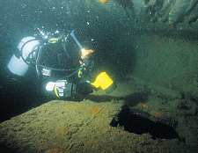
Open hatch leading into number 5 turret
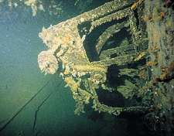
ammunition racks inside the turret
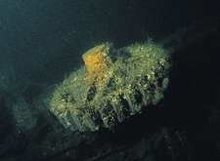
drive cogs for stern anchor capstans
The Kronprinz is at 58.53.39: 03.09.46. The seabed is about 38 metres down in cool, green Scapa water. She lies on her starboard main deck with most of her superstructure embedded in the silty bottom. She is virtually upside down and the only access to her decks is from the port side at a depth of 30m plus. The highest point of her upturned keel is about 12 metres from the surface.
The first impression when you dive her is size and confusion. This wreck is enormous and the profusion of steel, wreckage and general debris is overpowering. Her hull, however, is relatively smooth and uncluttered. Rather like a steel platform that has been well colonised by encrusties and brittle stars. There are four bilge keels that stand out quite nicely and give the diver some navigation marks. In places, the hull has been shattered by salvage work. The bow and stern both have salvage holes as does a large area some two thirds away towards the stern.
To get the most from this wreck you must get to the seabed and work on alongside or in. This means that you have to descend off the port side of the hull. This is a thrilling experience as you drop off into the gloom and pass by the tangled wreckage on the way down. At about 30m you arrive at the gunwales and you can then peer in as the deck runs at an angle to the seabed. It's dark, exciting and tantalising. So many shapes, but what are they? Much of the superstructure is buried, but towards the stern the turrets of the most aft guns can be found. To do this means entering a cave, with the deck the roof and the seabed the floor. If you are the first dive team there, then the guns can be clearly seen - a superb sight. They are upside down, the most aft barrels sticking in the deck. To see them closer means entering the cave and that's when you need to be careful. The silt stirs up quickly and without an attached reel it's easy to lose your bearings.
Along the gunwales are the secondary gun turrets - 7 per side. Although many are badly broken some can be easily distinguished amongst the general wreckage. The two masts of the vessel can still be seen as they stretch out away from the wreck. The seabed all around is littered with wreckage, as is the area towards the bows.
At the stern section it is easy to locate the twin rudders with the propeller shafts above. Although not quite as impressive as the Markgraf's they provide a convenient reference point with which to navigate the wreck. Along the starboard side, part of the hull has been removed to expose the inner parts. Divers can appreciate how part of the boat was built by finning along this section and peering inside. It is straightforward to traverse the length of the boat by travelling up this side.
The Kronprinz is not the deepest of the Scapa wrecks. With the keel at 12m she is more like a reef. It is easy to do a pleasant and leisurely decompression as you ascend up the sides of the boat. But good dive planning is essential to get the most from this wreck. The biggest problems are orientation, where to go and what to see. It's also easy to get carried away and extend your diving time. The Kronprinz is a big wreck and it takes many dives to get to know her.

Roedean (15m)
The Roedean is unfortunately quite badly damaged owing to clearance blasting. Furthermore she lies in a sheltered and somewhat muddy spot so it is all too easy for divers to stir the silt up. Nonetheless, she is a good second dive as she lies in 15 meters and there is a lot of wreckage on the seabed to greet the diver. With care, there is still a lot to see and piece together.
B109 (15m)

V 83 Destroyer (16m)

The V83 is a shallow Scapa wreck. She lies in two parts - bows in 8 metres and stern in 16 metres. Broken amidships, she makes a good second dive.
Although the shallow bow section is well covered with kelp there are hatches available for examination. The middle section has been extensively salvaged and so is well broken up. Nonetheless there are many bits of wreckage to be found. There is a 4-inch gun pointing upwards as well as the remnants of one of her torpedo tubes. The stern section is comparatively well preserved. It lies upright with an extant rudder, an anchor and attendant prop shafts. It is possible to enter the stern via one of the propeller guards.

Gobernador Bories (16m)

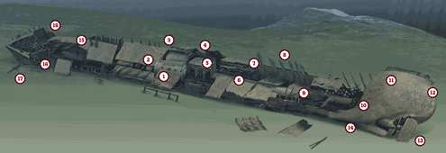

 | Although Scapa Flow is famous for the remains of the scuttled German Grand Fleet, of World War One, there are many other wrecks in the nearby waters.  To restrict access to Scapa Flow in both wars, old and damaged ships were scuttled in some of the entrances as deliberate obstructions to navigation. One of these blockships is the 2332 ton Gobernador Bories, built in 1882 and scuttled in Burra Sound in 1915.  Slack water in the sound is short. To get a good dive on the wreck you have to arrive early and jump in as soon as the current is slack enough to stay on the wreck. With a maximum depth of 15 or 16m, a no-stop dive of more than an hour is possible, so by the time you surface the current will be ripping along in the opposite direction.  When I dived the Gobernador Bories, a buoy line was attached just forward of the boilers (1), but this could change as lines break and are replaced.  In front of the boilers is a small donkey boiler (2). On the starboard side of the wreck, collapsed deck plates rest across the starboard boiler to make a tunnel inside the starboard side of the hull (3).  Various pieces of pipework and valves project into the tunnel from the end of the donkey boiler and plenty of light enters the tunnel through breaks in the plates and triangular ends forward and aft.  With the wreck being regularly swept by strong currents, there is no silt inside and good visibility makes navigation easy. Lines are not needed for this sort of wreck penetration, but I would recommend a fully redundant air supply.  Turning aft along the side of the boiler, the tunnel breaks into the open among the exposed remains of the engine room (4). The huge block of the steam engine (5) dominates the scene. The crankshaft and connecting rods are visible through the sides of the engine block.  From the rear of the engine, the partially buried arch of the propshaft tunnel projects from the square housing of the thrust bearing and marks the way to the stern (6). Largely intact, it is obscured in places by fallen sections of deck plate and hull.  A few metres back, the remains of the engine-room bulkhead is still upright, with some large sections of pipe attached to the inside of it (7).  The starboard side of the hull is generally higher than the port side, with ribs projecting above the line of the hull plates. Sticking up into a strong current, such ribs are a perfect home for soft corals and anemones. From the top, streamers of kelp waft in the current (8).  With typically good visibility you will be able to see the shadow of the largely intact stern from about halfway along the hold. The floor of the hold is a tangle of debris from the deck and sides. Among the debris here you will find the solid remains of the surround for one of the hold hatches (9) and, a little further back, a large winch (10).  The stern itself lists heavily to starboard and is surprisingly intact compared to the rest of the ship (11), demonstrating graphically how the ends of a ship are built to withstand much higher stresses than those parts in-between.  With decks gone, the inside of the stern is a grid of ribs and pillars, with shafts of sunlight streaming in from above. Right at the top, the steering mechanism is still attached to the rudder shaft (12).  Even at slack water there will still be some current running, so a cautious move is to drop close to the seabed before coming round the stern to view the propeller and rudder, both intact and in place (13). Two blades of the propeller are buried in the shingle seabed, with the hub just clear.  Following the line of the keel brings you back past the intact stern to the broken port side of the hold (14), where you can retrace your route back to the boilers.  Back at the boilers, the tunnel formed between collapsed decking and the starboard side of the hull (3) can also be followed forwards for 10m or more, almost halfway to the bows (15), coming out beneath a pair of solid deck bollards.  I was mobbed by fish in this tunnel. Divers must have fed the wrasse on this wreck, because they are almost tame. They readily approach, seeking a free meal, and follow you throughout the dive.  Crossing the wreck to the port side, another swimthrough (16) takes you right up to the inside of the bows. Like the stern, the bows are intact, but this time twisted to port.  There are no chains or anchors. Such useful fittings would have been cleared out before the ship was scuttled. Having said that, on the seabed to the port side of the bows lies a large iron pendant, perhaps the remains of an anchor with broken flukes (17).  To end the dive, there is little point returning to the buoy line. The current will be building up and the line would soon drag under with divers ascending it. My recommendation is to ascend to 8m while staying in the shelter of the bows (18), make a slightly deeper than normal safety stop while hanging on to the kelp, then blob to the surface before you drift too far from the wreck. |  | 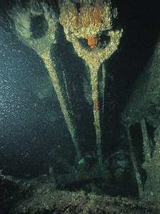  Connecting rods in the engine room  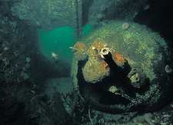  a small donkey boiler lies across the ship in front of the main boilers  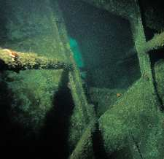inside the chain locker at the bows  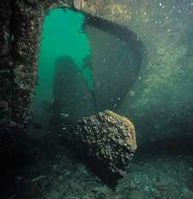the propeller is still in place, half-buried in the sand  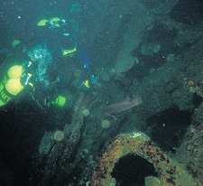exploring inside the stern section
  PASSIVE ROLE IN TWO WARS
  The Admiralty worried for years about the security of its anchorage for the Grand Fleet in Scapa Flow, writes Kendall McDonald. Long before the start of World War One, it began to fear that submarines might slip into the Flow and that its battleships would be sitting ducks.
  A German submarine would not in fact do that until U-47 torpedoed the battleship Royal Oak with the loss of more than 800 men in Scapa Flow in 1939. But in August 1914 the Admiralty's concerns crystallised into the idea of sinking blockships to keep out U-boats.
  Its plans were rushed forward after the periscope of U-18 was spotted that November. The U-boat left Scapa Flow without difficulty after her captain found that the Navy was so scared of U-boat attack that it had dispersed most of the fleet.
  There was little choice about the type of ships to use as blockships. The Admiralty bought what it could, used war prizes and added war-damaged ships, anything that would float long enough to be towed into position. Twenty-two vessels, 50,000 tons of shipping, were sunk within a year to close the four minor entrances to the North Sea. The main entrances were closed by booms, nets, minefields controlled from the shore and guns of all kinds.
  Five ships were used to block Burra Sound (two more were added in WWII). One of the earliest to hit the bottom in 1915 was the Gobernador Bories, a 2332-ton whaling ship based at Puntas Arenas, near Cape Horn. She had been used for some years for hunting whales in Antarctic waters near the Falkland Islands.
  The Gobernador Bories was almost a hulk when she was bought by the Admiralty - the Falkland waters are not kind to any ship, particularly one as old as this. The iron single-screw steamer had been built at West Hartlepool in 1882 as the Wordsworth, and had a long career as a cargo steamer before being bought by the Chileans for whaling.
  The fact that she is still ship-like after all that the fierce currents in Burra Sound could do over the past 85 years is a tribute to the men of West Hartlepool who built her, a mere 118 years ago!
  GETTING THERE: Ferries to the Orkney Islands run from Scrabster, Invergorden and Aberdeen. The longer ferry routes cost more, but have the advantage of shorter road journeys. The Scrabster to Stromness ferry is regularly used by divers and has a system for carrying dive gear for foot passengers, so you can easily leave your car on the mainland. Coaches from Inverness to Scrabster are scheduled to fit in with the ferry sailings. It is also possible to fly into Kirkwall.
  TIDES: The time of slack water in Burra Sound is a bit unpredictable, so skippers like to get there early and wait for the current to drop. Slack water is approximately 15 minutes before high water and 30 minutes after low water at Widewall Bay. Slack usually lasts for less than 30 minutes.
  HOW TO FIND IT: Co-ordinates 58 55 25N, 3 18 33W (degrees, minutes and seconds). The Gobernador Bories used to be easy enough to find by searching into Scapa Flow from the bows of the Inverlane. However, it might be more difficult now that the Inverlane has collapsed further and no longer breaks the surface. With the tide running, the Gobernador Bories causes quite a stir on the surface, and with an echo-sounder and GPS, finding it should not prove too difficult. A small buoy should be attached and pop up as the current slackens.

The Gobernador is unforgettable. She is one of those surprise dives that you don't really expect in Scapa. This is because of the exceptional visibility and the profusion of life around her. The boat lies in 16m of clean, well swept water. The bottom is sandy gravel with no silt, which gives it a very light background. She lies uprightish and is still quite a recognisable boat despite the fast current that runs around her and keeps her clean.
However, it is important to dive this wreck on the slack. With currents of up to 12 knots it is so easy to get swept off despite the shot line. Slack is around 30 - 45 mins and the current picks up within minutes, so good dive planning and an aware skipper is essential.
It is possible to get into the holds of the GB, and what a sight! With the clear limpid water, good light and prolific fish life, being inside rather resembles a small church with a greeny light pouring in through stained glass windows. The fish are quite unperturbed by divers - indeed they almost expect to be fed with the abundant sea urchins that abound around. Amidships there are boilers with a below deck section that may be safely penetrated. The bows are quite intact and there is a 'little room' out of which the diver can see a surreal pattern of kelp dancing outside maybe to the accompaniment of bubbles from divers underneath.
Divers can swim around the keel of the boat on the NE side. The propeller is still there (1988). The whole wreck is buzzing with life - fish (wrasse especially), sea urchins, and all manner of starfish and the most plenteous carpeting of kelp. The wreck is a riot of colour and life, and has a somewhat bizarre Mediterranean feel about it.
Unforgettable and unmissable.

F2 Escort vessel (18m)
The boat lies on its port side in 18m of quite cold water. The visibility is usually quite good. The bottom is shale and pebbly. There is an awful lot to see and discover. Not only the extensive wreckage but also a lot of interested sea life. The wrasses are particularly friendly - probably hoping for a sea urchin meal from a diver. There are enormous horse mussels, energetic scallops, many sea urchins and a couple of lurking conger. The wreck has been extensively salvaged around the stern. Unrecognisable wreckage lies strewn all over the seabed. Wreck ferrets will be in their element. Towards the bows a more recognisable shape emerges. The bridge structure is quite intact and the mainmast still lies across the seabed. On the foredeck there is a well-preserved 4-inch gun turret with its breech mechanism exposed for inspection by the interested diver. Anchor chains are clearly visible as are the paraphernalia of cleats and capstans.
Near to the F2 (about 40m off the starboard midsection) is a barge that was used in salvage work. The barge sank in 1968 during a storm. Inside its hold can be seen one of the anti aircraft guns that was being salvaged from the F2 plus a lot of other bits and pieces. If you are the first pair of divers then it is pleasant to swim into the hold of the barge and explore. At one end you will see a worktable with a vice on it plus tool cabinets. There are a couple of passageways. Underneath the barge there are quite a few ling and conger.
The water seems particularly cold around the F2. There is a lot to see, and there are many surprises. A good second dive.
Dresden (18-35m)
The Dresden lies in 35 metres with her nearest surface point at 18 metres. In some ways she resembles the Köln, but her stern is more intact and gives the diver a better appreciation of that area. She lists at a slighter angle than the Köln and part of her deck has rotted and dropped away to reveal some of the innards. The bridge is intact and the whole superstructure together with the mainmast makes for excellent diving. The bow anchor chains are present, but like the Köln, the gun platforms are empty. Towards the stern the officers' accommodation section is obvious with its windows and open doorways. Both stern guns still remain, as does the stern anchor.
The winter storms of 1996/97 have affected this wreck. The deck has moved away from the hull, so opening it up and making some swim throughs easier.

Köln (20-35m)

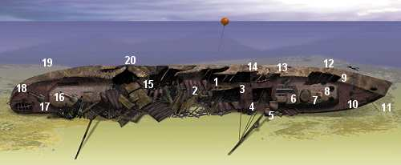

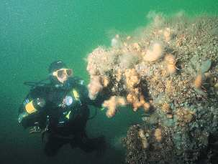
The Köln
This warship's fighting history might have been unimpressive, says John Liddiard, but as a wreck it is the most intact of all the German Fleet at Scapa Flow
Illustration by Max Ellis
The wrecks of the scuttled German High Seas Fleet in Scapa Flow include two Dresden II class cruisers, the Köln and the Dresden. Although basically identical ships, the Dresden is one of the more broken German Fleet wrecks, in stark contrast with the Köln, which is regarded as the most intact of all.
Local skippers maintain buoys on all the main Scapa Flow wrecks. On the Köln, the line is usually attached to a boat davit just forward of the break in the hull (1).
Immediately below the line is one of the 3.4in secondary anti-aircraft guns mounted high on a pillar above deck (2). Originally the gunners would have stood on an open platform attached to the pillar from which they could work the gun, but this platform has long gone.
Forward from this gun are the flues from the funnels (3). The funnels have broken off, but some parts are still recognisable among debris on the seabed beneath. As usual with warships, the flues are blocked by armoured grilles, to protect the boilers below from falling shells.
Next comes the bridge and main mast. The mast is spectacularly intact, with supporting cables home to dangling arrays of plumose anemones (4). Two spotting platforms are located a short way up the mast (5).
Beneath the mast, the main bridge area retains its overall structure, but the sides have rotted away to leave a cross-hatched array of supporting beams (6).
Forward of the bridge is the armoured conning tower - a solid-looking cylin-drical structure with slit windows. On the roof is a T-shaped device that, on a modern ship, could be a radar scanner, but is in fact the rangefinder for the ship's guns (7).
An arrangement of lenses and prisms would be used to calculate range from the parallax between images viewed through opposite ends of the range-finder. The optics from the rangefinder were removed in Germany before the Köln was surrendered to the British. Apparently the Germans regarded the secrets of their rangefinder optics as something worth keeping to themselves when the fleet was interred.
The Köln originally mounted two bow turrets side by side on the forward deck (9), but all that remains are two debris-filled holes in the decking where the turrets used to be, and an armoured locker just behind them, perhaps used to store ready ammunition (8).
The last feature before the bow is a pair of capstans with anchor chain dangling between them (10). Beneath the starboard bow, a length of chain runs out across the seabed, but I have never swum to the end of it to look for an anchor (11).
Back towards the conning tower on the port side of the hull, several missing plates and a gouge in the deck provide easy access to the spaces below deck, with turret mechanisms and drives for the capstans easily accessible (12).
Following the shallower port side of the deck back past the bridge, you come to the remains of one of the main 5.9in gun turrets (13). This turret is unusual in that half of the armour plating has fallen away, leaving the gun mechanism more accessible than on the more intact turrets at the stern. The corresponding starboard turret is presumably buried among debris on the seabed.
Other features along this side of the hull are davits for the ship's boats (14), the last of which hosts the buoy line (1).
With a maximum depth between 33 and 36m, the route so far gives a relatively brisk no-stop dive or a more leisurely dive with a moderate amount of decompression stops.
Unless you are breathing an optimum nitrox mix, are carrying lots of it, and are prepared for lengthy deco stops, you will probably want to save the second part of the route for a later dive.
Behind the davits and gun pillar, the hull has been broken open for salvage (15). Over a number of years, the weakened structure has collapsed further, leaving a tangled mess of debris, including the aft mast and superstructure.
Crossing the debris, the wreck soon regains its structure, with a raised deck supporting one of the rear turrets. This turret is intact, showing the full armoured shield covering the front, top and sides of the turret, but leaving the rear open (16). The 5.9in gun barrel points about 20¡ to port of aft.
Further back and on the main deck, the other rear turret is also intact (17). It must be something about the balance of the turrets, because the rearmost turret points upward at a similar angle to the previous one, as do similar intact turrets on the other scuttled cruisers Dresden and Brummer.
A few plates have broken free of the deck, leaving holes too small to enter. At the stern, a single capstan and chain hold the kedge anchor in place against the rear of the hull (18). A diversion along the keel reveals the remains of the rudder and propshafts (19). The main life on the hull plates consists of tunicates and brittlestars.
Returning to amidships along the shallower port side of the deck, the break in the hull is soon reached. With decom-pression stops now mounting rapidly, it is probably easier to release a delayed SMB from the start of the break (20) than work across it back to the buoy line.
As mentioned earlier, the Köln is of the same class of cruiser as another wreck in Scapa Flow, the Dresden. The Dresden is similar in layout to the Köln, but lies on its port side, with considerably more damage to the amidships and stern areas. Its bow used to be reasonably intact but, over the past couple of years, the plates have started to fall away from the ribs of the hull.
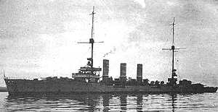
DANGEROUS ONLY IN DEATH
The light cruiser Köln was the last of the 74 ships of the surrendered German High Seas Fleet to reach Scapa Flow, but among the first to obey the order to scuttle. All 5531 tons of her went down, sternfirst with a starboard heel, and all 510ft went out of sight at 1.50pm on 21 June, 1919, writes Kendall McDonald.
The Köln, named after the city of Cologne, did not have much of a war record. She was built at the Blohm and Voss Hamburg shipyard to replace the sunken Cöln (German spellings changed around this time) and launched in October, 1916, but was not completed and taken into service until January, 1918.
She was a high-speed mover with a heavy punch. Her two sets of turbines and twin propellers could drive her along at nearly 30 knots, even when fully loaded with ammunition for her eight 5.9in and two 3.4in AA guns, torpedoes for her four deck tubes, and 200 mines. That is not to mention the weight of a large amount of 2.4in and 3.9in armour. Her crew numbered 559.
The Köln became part of the Second Scout Group, escorting U-boats through the swept channels of German minefields in Heligoland Bight. Sometimes she laid some of her own mines. Her chances of action against the British Fleet diminished as German naval mutinies spread, but she and the Second Scout Group remained loyal and stayed at sea, awaiting orders.
Those orders, when they finally came, were to join not battle but the Internment Fleet. Leaky condensers meant that she finally limped into Scapa Flow behind the rest of the German Fleet.
However, she nearly did sink one British warship. A destroyer went alongside to try to stop her sinking and just missed being taken down by the Köln as she rolled over for her final plunge.
The Köln is in good condition, and makes for an excellent dive. The boat is in 35 metres of water and lies on its starboard side with a very slight list. Because of the orientation of the wreck, the Köln is quite light when the sun is out and it is easy to make out many of the structures on her. There are many ways of diving the Köln. You can descend straight to the seabed at 35 metres and then work your way up the vertical deck. Or else land mid-ships on the port rail and either go to the bows or stern making sure to buoyant on mid deck level (about 25 - 30 meters). Or stand from one end and go straight to the other. The Köln is large enough and interesting enough to make a few dives necessary before you get the picture.
The highest point is 20 metres, which is the midpoint port rail. It makes a convenient place to start a dive from particularly if the shot is near here (which it often is). Although it is possible to stay around this depth and inspect a port side mid-mast 6 inch gun whose barrel points upwards, you need to go deeper to see the best of the wreck. You could continue to the stern and pass over a salvage hole towards the stern most pair of 6-inch guns. They are both in good condition. By swimming over the stern you can then land on the long rudder (there is no propeller!). An impressive sight.
Or else move along towards the bows and pass the lifeboat davits that dangle over the side of the boat. You can look over and see the deck of the boat plunging down to the dark seabed some 15 metres below. As you approach the bows the depth increases down to around 28 metres. Near the sleek almost knife-edge bows are two capstans with the remainder of the anchor chains. Behind the capstans working back toward the mainmast are the platforms of two 6-inch guns, which have now disappeared. The mainmast still has a basically intact structure.
When diving this wreck it is easy to imagine being on a fast and lean cruiser. Her remaining guns are well-preserved and even unpromising items like lifeboat davits and the holes left by her absent funnels are all memorable and add to the unique atmosphere that this wreck creates.

Brummer (20-36m)

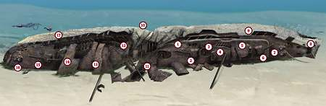

As with most of the Scapa Flow wrecks, local dive boats maintain a buoy line on the Brummer, which lies in 33m. Here the line is usually attached just forward of the break in the hull left by salvage work on the engine room (1).
Immediately beneath the line is the centre main gun turret (2), just a 5.9in gun and a bit small compared to the nearby battleship guns, but nevertheless worth a look.
The nice thing about the cruiser turrets is that they are open at the rear, making it easy to have a good view of the breech mechanism and controls.
This turret is also a useful navigation aid, with the gun pointing towards the rear of the ship; the opposite direction is the bows.
Following roughly along the centre-line of the ship, immediately forward of the gun is a hole where a funnel used to be (3). This is not a practical way to the engine room, as the flues were secured by armoured gratings as a defence against plunging shells.
If you want to get in among the remains of machinery, your best route is further back in the salvage hole.
Next is the navigation bridge, an open structure of platforms and latticed supports (4). The mast is towards the forward end of the superstructure, unlike the cruisers Kšln and Dresden, where the mast is at the rear of the superstructure.
A solid-looking cylindrical structure with slit windows in front of the bridge is the armoured conning tower (5), where the ship would be controlled during battle.
On the roof is the T-shaped central rangefinder for the ship's guns. An arrangement of lenses and prisms would be used to calculate range from the parallax between the images viewed from opposite ends of the rangefinder. However, these optics were removed in Germany before the Brummer was interred in Scapa Flow.
Continuing forward, in front of the conning tower is the forward gun turret, similar to the amidships gun, with the gun barrel pointing about 20° to port, and an open back (6).
The last feature before the bow is a pair of anchor capstans (7), with lengths of chain draped across the gaps to the chain-locker and hawse pipes. The last few metres of the bow has broken and twisted towards the seabed, leaving a hole back beneath the bow deck (8).
If you are into a bit of wreck penetration you can find your way back amidships between decks. It's not as complex as it sounds, because many internal bulkheads have collapsed and hatches between decks are all open.
Light enters from above where plates in the hull have been removed or come loose with age, also providing easy routes out before the break (9).
On the way you will pass the mechanisms driving the anchor capstans and the forward gun. The space round the anchor capstans is interesting; it looks as if it was designed for a gang of sailors to work the capstan by hand if the powered mechanism should fail.
Back at the starting point (1), there is a choice of ascending and saving the stern of the Brummer for a later dive, or continuing aft.
The debris here is quite complex, but heading towards the keel you can find piles of coal in one of the coal bunkers (10). Like most German warships of the era, the Brummer was powered by a mixture of oil-fired and coal-fired boilers. There are also scattered lumps of coal on the seabed (11).
From the aft side of the break to the stern, the decks have started to peel away from the hull (12).
Some areas of deck are complete, and in other areas the deck plates have also peeled clear. The overall confusion makes it hard at times to tell just which deck you are following.
The Brummer was a mine-laying cruiser, with an internal rail network used to move mines about the ship and push them out across the stern deck and over the side. It's a similar arrangement to that of the mine-laying freighter Port Napier (Wreck Tour 12, February 2000), albeit on a smaller scale.
Having swum through the ship between decks it is easy to imagine where the mine tracks would have been, but no one I have spoken to has seen the actual tracks. Maybe they were removed at some point in the Brummer's life, or perhaps they were salvaged.
The rear superstructure is partially buried beneath debris from the hull, the location being given away by a protruding section of mast (13).
Further towards the stern, the upper stern gun turret is partially obscured by a fallen hull plate, making a triangular swim-through past the gun (14).
Behind this and one deck down, the other stern turret is in the open (15). Both are similar in construction to the earlier turrets with an armoured cover over and an open rear, and both are also pointing slightly to port from the stern,
Finally there is a single anchor capstan (16), still firmly connected to the stern anchor that is nestling in tight against the stern of the hull.
From the stern it is easy to follow the port side of the deck back to the break, exploring some of the gaps between decks on the way (17). Once at the break, it can take some thinking to get across to the buoy line and ascend. If time is pressing, releasing a delayed SMB can be a lot more convenient.

THE DEADLY DUO
For her size she was fast. When she finished her sea trials in 1916, the German Navy knew that the 4,308 ton light cruiser Brummer was going to be as good as the other eight in the Bremse class, possibly even faster as her 33,000hp turbines and twin props gave her a steady top speed of 28 knots.
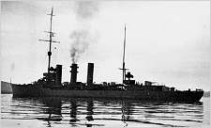
It was a speed that she soon put to use, writes Kendall McDonald. Though planned as a fast minelaying cruiser, the 462ft-long Brummer quickly teamed up with her sister ship Bremse and started harassing the Allied Scandinavian convoys with her 5.9inch guns (two mounted at the stern and two at the bow).
The "Two Bs", as they were known to Norwegian convoy commanders, carried out a massacre of nine Allied and neutral ships on 17 October,1917, after sinking the escorting destroyers Mary Rose and Strongbow. The two cruisers worked together for the rest of the war. Their names suited their actions - Brummer is a wasp in German, and Bremse means horsefly.
Despite the number of actions in which they took part, both of these armour-plated warships went through the rest of the war unscathed. After they were scuppered with the other light cruisers in Scapa Flow, only the Bremse was salvaged.
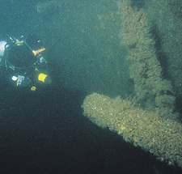
Approaching the central 5.9in gun turret at the start of the dive
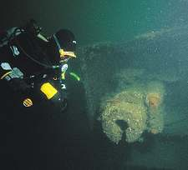
the backs of the gun turrets are open, allowing easy inspection of the breech mechanisms
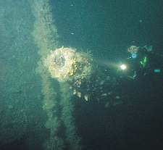
below decks the mechanism looks as if it might have been designed for manual power in an emergency
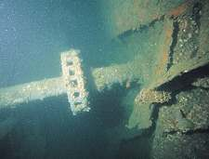
one of two anchor capstans at the bow
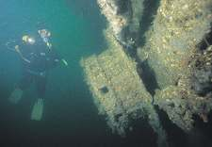
looking along the rearmost 5.9in gun

The Brummer can be a darkish dive that is different from the Dresden cruisers. Partly this is because of her orientation and partly because this is a more open wreck that divers can partially enter. She lies in 36 metres with 20 metres being her shallowest depth. She lies on her starboard side with her bows slightly shallower than her stern. At the bows you can see the anchor capstans with the chains still hanging off them. Behind them lies the 6-inch bow deck gun with its armoured shield. Aft of this is the control tower with its narrow viewing slits and open access door and directly behind is the bridge. The bridge and mainmast structure is largely intact, and presents the diver with a mass of wires and cross rigging. Just aft of the bridge is the mid 6-inch gun with its barrel facing astern. Mid-ships is a mess of salvage damage. It is possible to enter the ship here and explore her interior. Further back at the stern can be found another 6-inch gun. The rudder can be seen lying on the seabed.
Since the winter storms of 1996/97 the deck has moved away from the hull, which has opened the wreck somewhat. Some swim throughs are easier.

Koenig (20-40m)
The Koenig is virtually upside down in 40 metres of water at 58.53.13: 3.09.07. Her starboard side is only a few feet above the silty bottom whereas the port side is well embedded. Her keel is at 20 metres. Life has not been so good to the Koenig. She has been extensively salvaged, not least for the radiation free steel some of which has found its way to the moon in the 1969 expeditions. A lot of the hull has been blasted apart, which at least gives the diver some appreciation of the inner bulk of these battleships. Amidships her starboard casemate guns are clearly visible. Underneath her deck the centre turret of her 12-inch guns can be seen half buried in the mud. Unfortunately, the guns cannot be seen.
The Koenig is now a pile of wreckage, but an excellent dive for wreck ferrets. She is big and quite intimidating.

Markgraf (24-45m)
The Markgraf lies on her port side at 58.53.31: 3.09.55. The seabed is around 45 metres, with a least depth of around 24 metres. This is the deepest German battleship. Like all the battleships she is virtually upside down so to get underneath her means getting to the gunwales at around 38 metres. Depending on the shot position, the diver lands on the upturned hull and looks over the side into 20 metres of gloom and darkness. It is important to ensure that you are on the right side! Off you go, skydiving down the side of the hull. If the shot is amidships then you should see the 6-inch guns pointing out as you approach the gunwales at 38 metres. This gives a useful reference point, as the direction that the guns are pointing will show you where you are on the wreck. Amidships, the gun barrels point out 90 degrees to the hull, whereas towards the bows the guns point towards the bows. So you can hang in the water above the gun barrels and navigate yourself accordingly. Below you it is dark as the decks run sharply under the hull.
As you descend towards the unseen seabed at around 45 metres the underneath of the wreck reveals itself as a dark, imposing cave. Your torch beam just seems to go nowhere. To venture into this cave takes previous dive planning and some courage. But once inside it's not so bad. You can see the green of the outside as the bulk of the 25000-ton ship lies above you. It is possible to swim underneath most of the wreck. Just follow the coal brick road. In the middle you will come across part of the midships crane. One diver goes above and the other underneath. Somewhere in the darkness of the cave lies one of the 12-inch gun turrets, but it takes adventurous diving to find it.
There are 2 enormous rudders on the stern that are worth visiting. The hull is largely intact and well fitted with thick slabs of armour plating, some of which have peeled away. Some blasting damage can be seen near the bows. The bows themselves tip over sharply into the darkness.
The Markgraf is an exciting and challenging dive. Its depth and position are such that good dive planning is essential. The seabed is dark and silty and so on a dull day this wreck can be gloomy and quite intimidating. It is a cleaner wreck than the other battleships with less obvious damage done by salvage work.
Dimensions: Length 177m, Beam 30m, Displacement 25,797 tonnes
Proposed timetable:
 | am | Depth | pm | Depth
Sunday | Karlsruhe | 12-26m | F2 Escort Vessel | 18m
Monday | Kronprinz Wilhelm | 12-38m | Dresden | 18m-35m
Tuesday | Koln | 20-35 | Roedean | 15m
Wednesday | Markgraf | 24-45m | B109 | 15m
Thursday | Koenig | 20-40m | V83 Destroyer | 16m
Friday | Brummer | 20-36m | Gobernador Bories | 16m

From the web site, some information on Scapa:

What was the water like?
Well Scapa water is cold. In July the water temperature was 12 Centigrade. In June 10 or 11 Centigrade is usual. If you add this to the typical Orkney weather then good dry suits and woolly hats are a must - even in high summer. Water visibility was good - one memorable dive on the Kronprinz gave 15m Vis. from the surface we could see the hull back just 12m below us. The tidal streams of Burra Sound gave us 20m plus visibility. In the Flow tidal streams are hardly existent. Although we could feel a slight fetch on the Markgraf this was no problem. Burra Sound is quite different. Tides are very strong here (6 knots and more), and the slack doesn't last for long. When we dived the Gobernador Bories we had to pull energetically down the shot line and get into the wreck quite smartly. Within 10 minutes slack arrived and we could swim around the wreck with no problem. 20 minutes later and an opposite current rapidly developed.

Summary of details:

Leave at 04:00 2nd June 2006
Travel to Inverness

Accommodation:
Inverness Fairways £22.50 each (payable on arrival)

Leave at 07:00 3rd June 2006
Travel to John O’Groats.

Ferry from Catherine’s Bay 13:45 3rd June 2006

Charter:

Orkney Divers
www.orkneydivers.com
01856831205

Notes:

Own towels required.
Tea and coffee facilities available at each accommodation.
Repellant required due to mozzies.
250 Bar max pumping pressure.
No ladder.

